CELIA-U Quick Start Guide
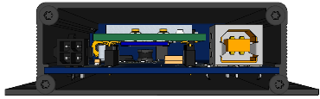
- Remove 4 screws and the rear panel using the Philips screwdriver:
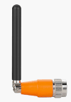
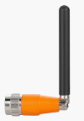
- Install the SIM card
- Close the rear panel
- Install the antenna(s)
- Connect the USB cable between CELIA and your computer’s available USB port:
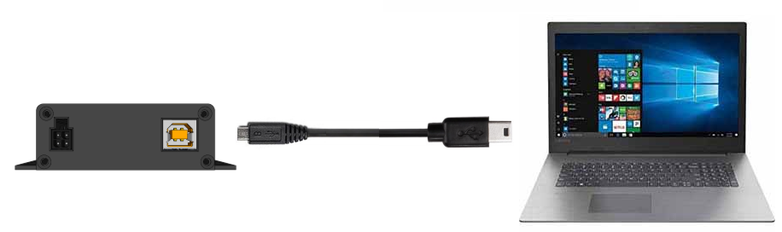
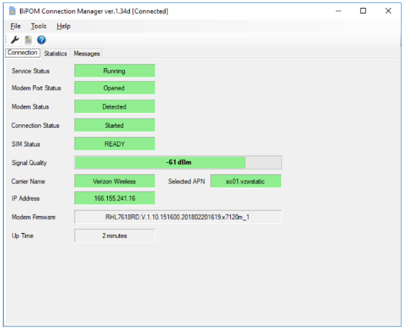
- Unpack and connect the AC power supply to power connector of CELIA
- Green light on CELIA should turn on. If not, check the connections.
- Download and install the driver and Connection Manager
for the specific version of your CELIA.
CELIA models:
CELIA-U-7588-V
CELIA-U-7588-T
CELIA-U-7648
CELIA-U-7618RD
Use BiPOM Connection Manager on Windows: www.bipom.com/products/us/4387033.html
- For other operating systems, contact BiPOM Electronics (www.bipom.com) for assistance.
- Once the Connection Manager shows CELIA as connected, your computer should be able to access the internet through CELIA. Be careful on data usage as Windows can transfer large amounts of data quickly over available internet connections and use up the SIM data plan.

