GadgetPC

&

SAM-BA

Document Revision: 1.01
Date: 17 October, 2008

- It is necessary to fix a minor bug of GadgetPC rev 1.01

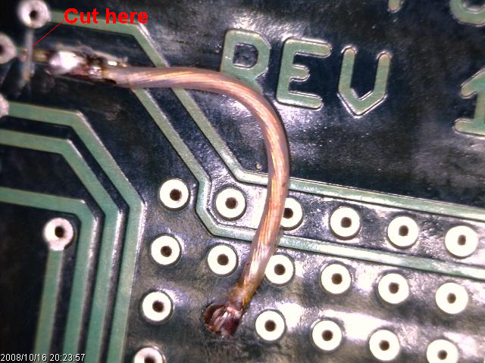

- Install X2 jumper to a GadgetPC board.

- AT91 In-system Programmer can be downloaded and installed from
http://www.atmel.com/dyn/resources/prod_documents/Install%20AT91-ISP%20v1.12.exe
The installation includes SAM-BA V2.8 package.

- Connect the GadgetPC board to any USB HOST port of a PC.
The board has to be detected immediately.

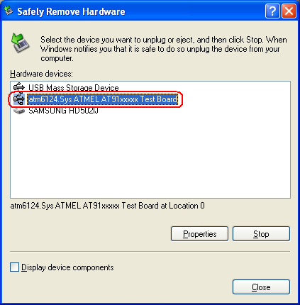

Note. If you face any problems with this step please try to connect a Mini-Max/ARM-S board
(or any board based on AT91xxxx chip). The result has to be the same.
If the problem is still not solved:
- remove some ( or all) USB drivers. Maybe some of them conflict with ATMEL driver;
- connect ATMEL technical support.

- Download http://www.bipom.com/support/gadgetpc/gadgetpc_samba208.zip
and unzip to any folder of your HDD.
Copy all the unzipped files/folders to C:\Program Files\ATMEL Corporation\AT91-ISP v1.12\SAM-BA v2.8\lib
Note. C:\Program Files\ATMEL Corporation\AT91-ISP v1.12\SAM-BA v2.8\lib\boards.tcl
has to be replaced with the corresponding file from the zip file.
GadgetPC folder with its files has to be under C:\Program Files\ATMEL Corporation\AT91-ISP v1.12\SAM-BA v2.8\lib
See the screenshot below to understand the file structure.
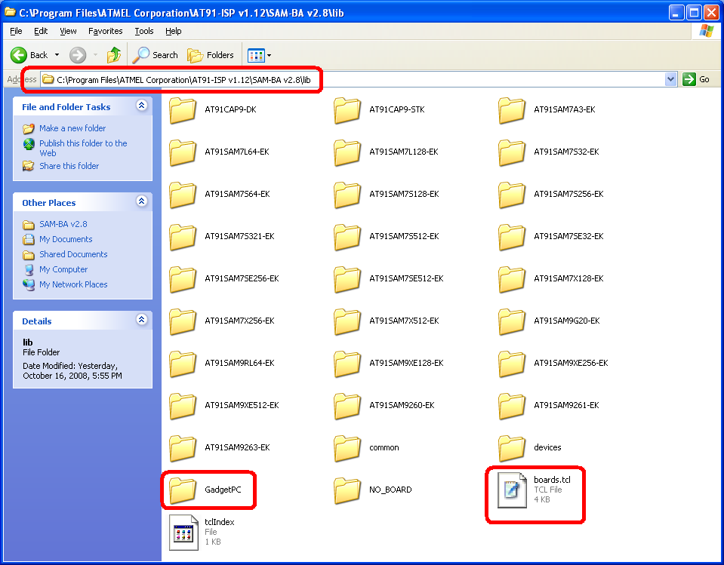

- Run C:\Program Files\ATMEL Corporation\AT91-ISP v1.12\SAM-BA v2.8\SAM-BA.exe

- Select “\usb\ARM0” and “GadgetPC” from pull-down lists and press “Connect”

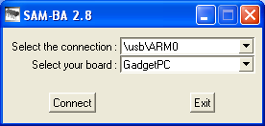

- Select “SDRAM” and press “Execute” button
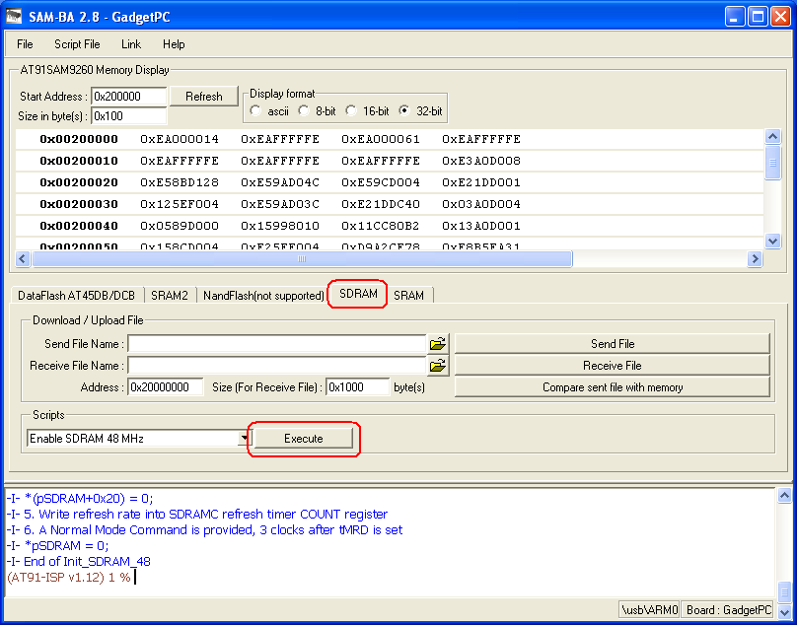

- Select “DataFlash AT45DB/DCB” and press “Execute” button
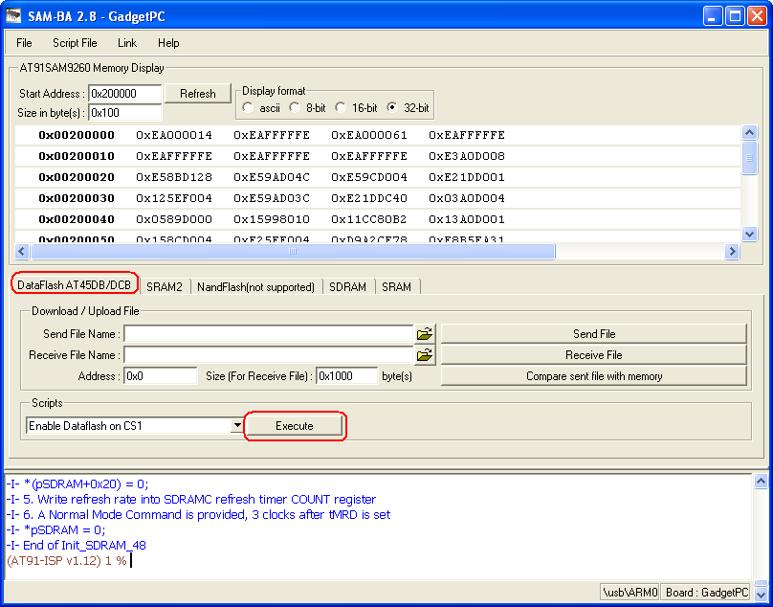

- Try to send/compare any test BINARY file to the DataFlash
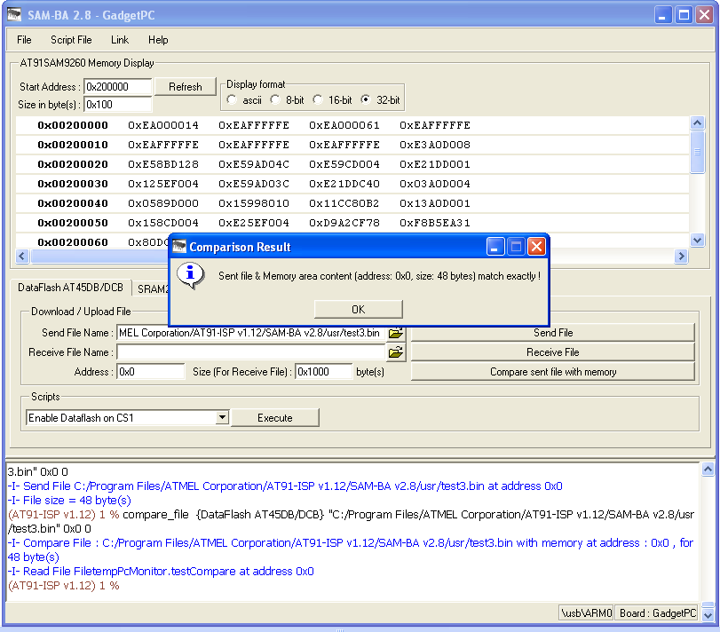

- Try to send/compare any test BINARY file to the SDRAM
